**Nearbuy WebApplication – Design Document**

Nearbuy is a hyperlocal online platform that enables customers and local merchants to discover and engage with each other through the use of discounts and coupons.

**Tech Stack:**

Technology used for implementing this web application:

1. .Net Core with MVC
2. SQLserver
3. Javascript
4. Html
5. CSS

**Persona Functionality:**

**1)User:**

* Can purchase services
* Update their profile details
* Refer the website
* Track their orders
* Track the credits
* View all the categories of services
* Make dummy payments

**2)Business:**

* Can list their services
* Can add or remove services
* Can edit their business description
* Can alter their pricing
* Can check the status of the orders purchased from their business

**3)Visitor:**

* Visitor can visit the website
* View the home page
* Select the location
* View the services, products and offers

**4)Support:**

* Can check and track the error logs

**5)Admin:**

* Admin login to the website
* Manage dealers
* Manage transactions
* Approve new products.
* Role authoring privilege

**Nearbuy UI Design:**

**Home Page:**

4

5

3

1

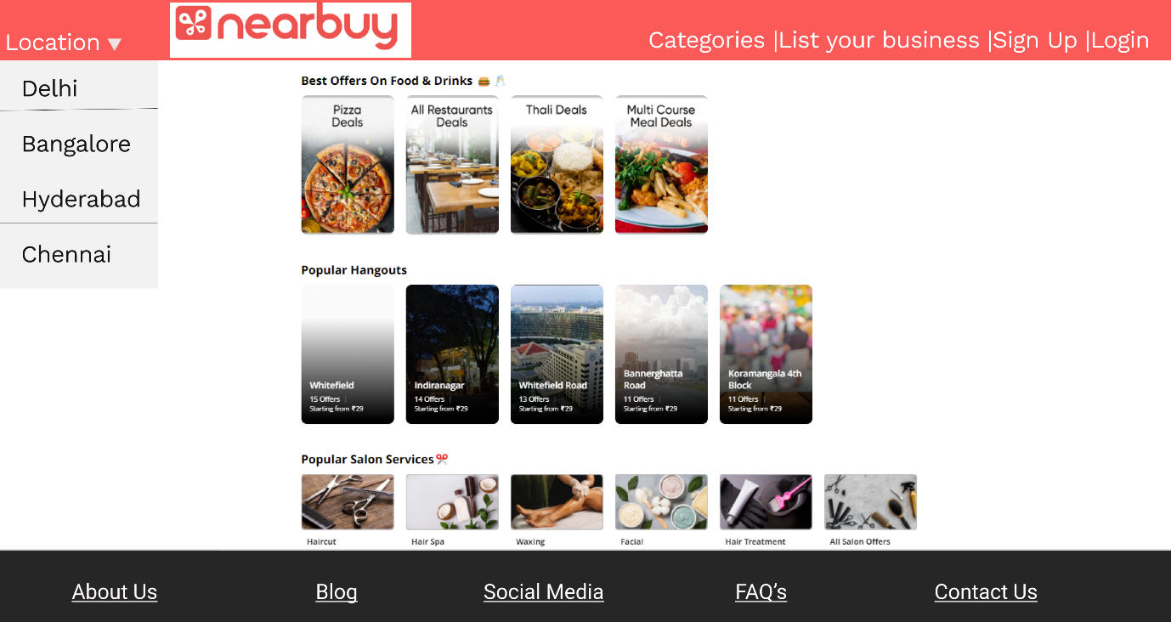

7

6

2

|  |  |  |
| --- | --- | --- |
| **S. No.** | **Feature** | **Description** |
| **1.** | **Location** | Contains a dropdown list of locations. The user can select the particular location for which they want to avail the services |
| **2.** | **Login** | Contains the link to the login Page |
| **3.** | **Sign Up** | Contains the link to the User registration page |
| **4.** | **List your business** | Contains the link for the Business registration page |
| **5.** | **Main Page** | Contains all the business options available for the selected location |
| **6.** | **Categories** | Contains a dropdown list for all the Categories of the services available on the website |
| **7.** | **Footer** | The footer contains the link to the information, blog, Social Media, FAQ and the contact information for the website |

**Sign Up And Login:**

**Customer Sign Up :**

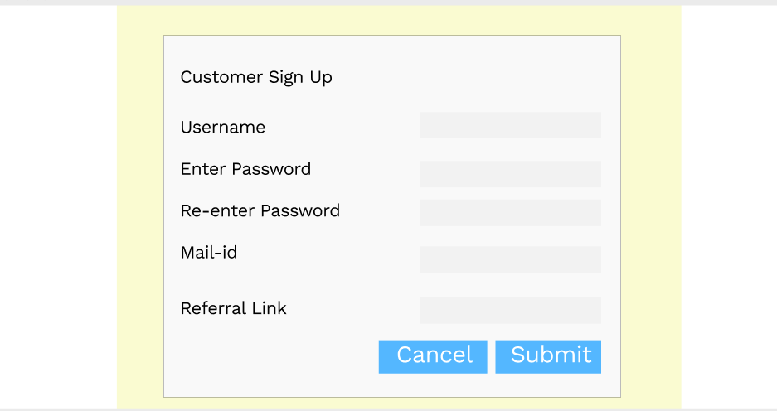

|  |  |  |
| --- | --- | --- |
| **S. No.** | **Feature** | **Description** |
| **1.** | **Username** | Contains the username of cutomer user |
| **3.** | **Enter Password** | Contain the password |
| **3.** | **Re-Enter Password** | Contains confirmation of password |
| **4.** | **Mail Id** | Contains the valid email id |
| **5.** | **Referral Link** | Contains the shareable referral code |
| **6.** | **Cancel** | Allows the customer to cancel the details |
| **7.** | **Submit** | Allows the cutomer to navigate to home page. |

**Business SignUp:**

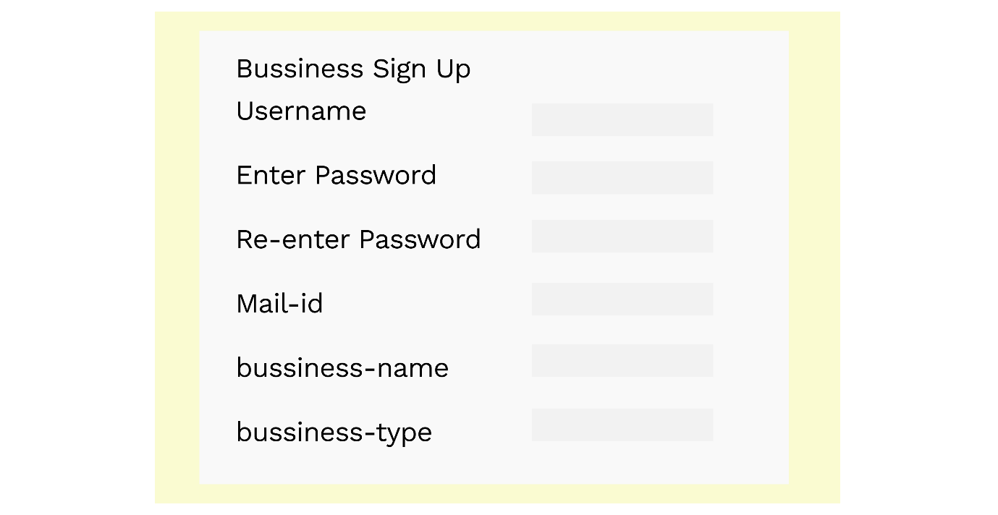

|  |  |  |
| --- | --- | --- |
| **S. No.** | **Feature** | **Description** |
| **1.** | **Username** | Contains the username for the Business User |
| **2.** | **Enter Password** | Contains the hidden password |
| **3.** | **Re-enter Password** | Contains the Hidden Password |
| **4.** | **Mail-id** | Contains the email id for the registration |
| **5.** | **Business-name** | Contains the Business Name |
| **6.** | **Business-type** | Contains the Type of Business |

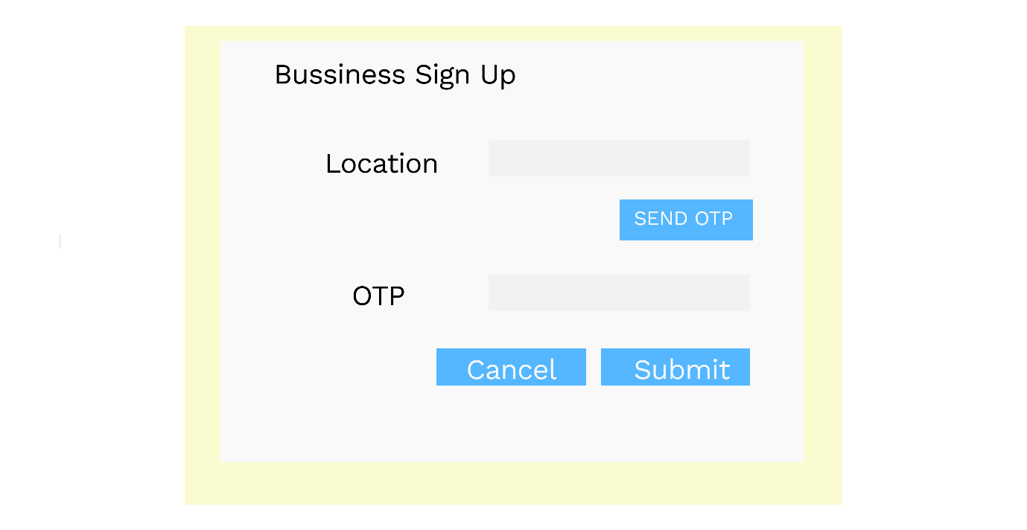

|  |  |  |
| --- | --- | --- |
| **S. No.** | **Feature** | **Description** |
| **1.** | **Location** | Contains the location of the Business |
| **2.** | **Send OTP** | Sends OTP to registered mail-id |
| **3.** | **OTP** | Contains the OTP |
| **4.** | **Cancel** | Withdraw registration |
| **5.** | **Submit** | Submit registration |

**Sign In :**

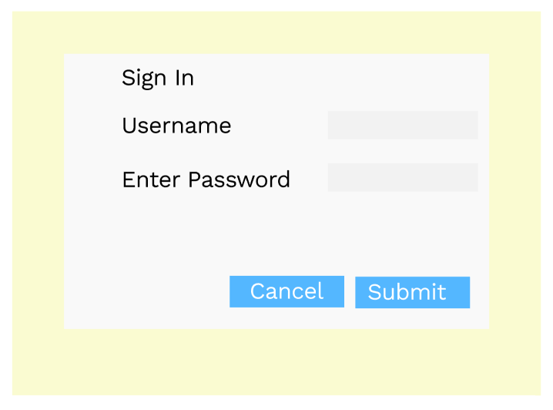

|  |  |  |
| --- | --- | --- |
| **S. No.** | **Feature** | **Description** |
| **1.** | **Username** | Contains the username of cutomer user |
| **2.** | **Enter Password** | Contains the password |
| **3.** | **Cancel** | Allows the customer to cancel the details |
| **4.** | **Submit** | Allows the cutomer to navigate to home page |

**Logged In Customer:**

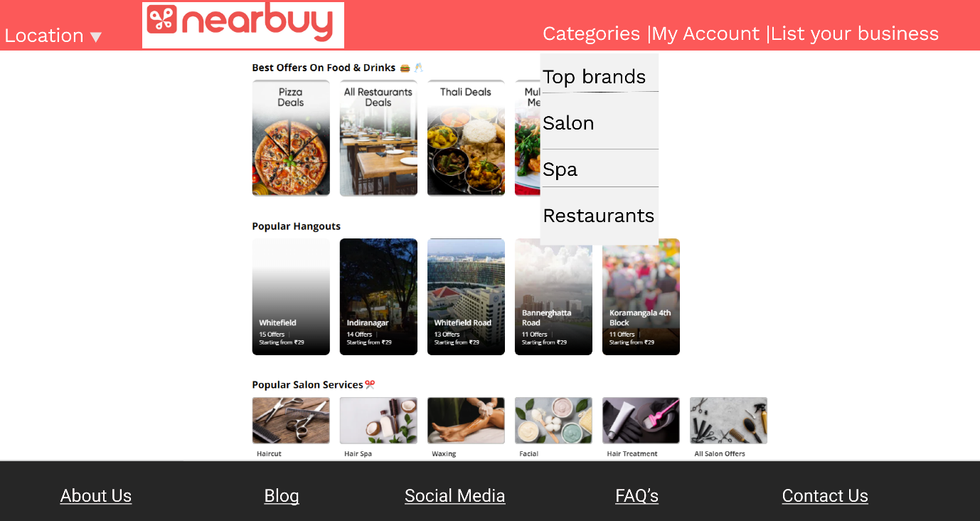

Once the user has logged in, the above screen would be visible to them. They can check out their account details using My Account

**Buy Now Page:**

On Clicking on any service provided on the business Page, the user would be redirected to the Buy Now page.

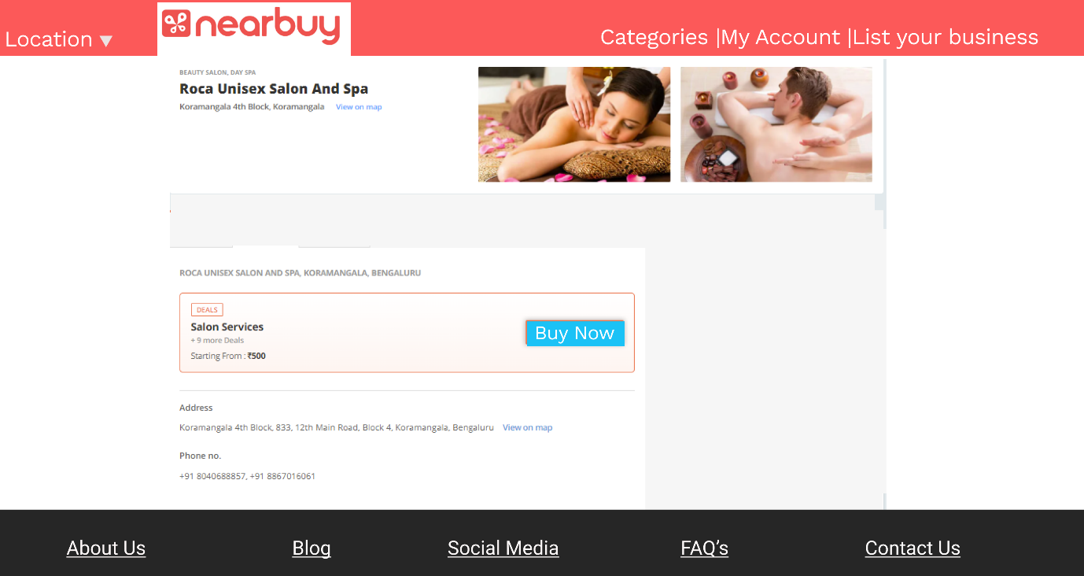

* This page would contain all the deals and offers provided by business
* If the user clicks on Buy Now, they are redirected to the payment gateway

**Payment Details:**

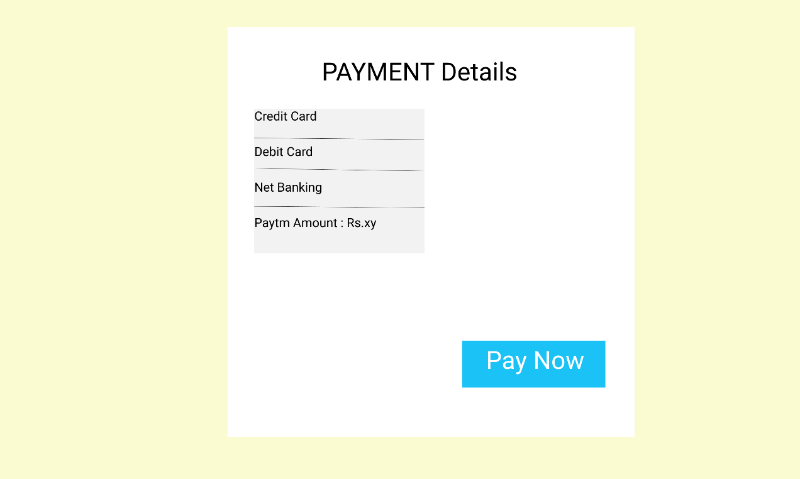

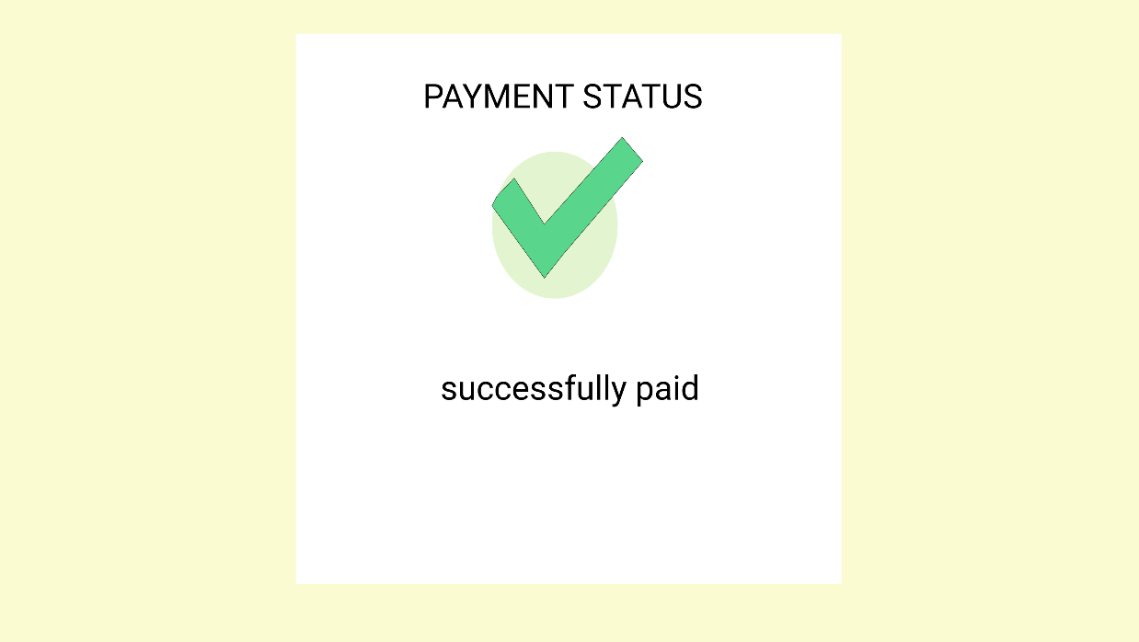

* When the user clicks on the Buy Now option for any product, they are redirected to the Payment Details page. This is a dummy Payment Gateway.
* On clicking the Pay Now button, the user would be redirected to the My orders Page

**My account**: Contains a drop down which has the following option:

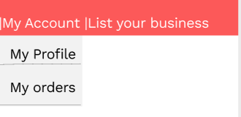

|  |  |  |
| --- | --- | --- |
| **S. No.** | **Feature** | **Description** |
| **1.** | **My Profile** | It contains the link to the User Profile |
| **2.** | **Login** | It contains the link to the page containing the order details and the rewards for the signed in customer |

**My Profile:**

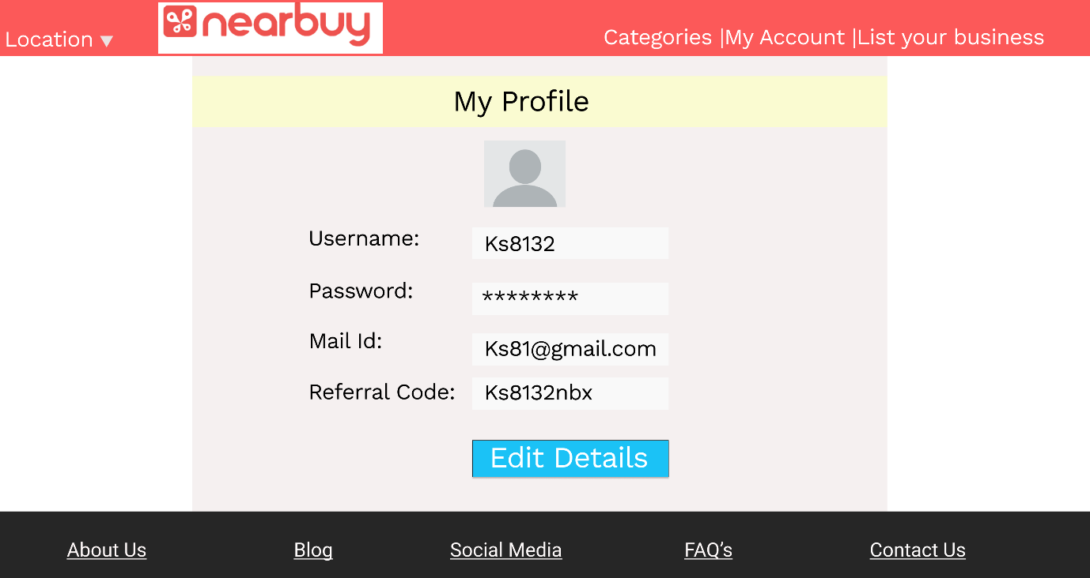

|  |  |  |
| --- | --- | --- |
| **S. No.** | **Feature** | **Description** |
| **1.** | **Username** | Contains the username for the signed in user |
| **3.** | **Password** | Contains the hidden password |
| **3.** | **Mail ID** | Contains the registered email id for the user |
| **4.** | **Referral Code** | Contains the shareable referral code |
| **5.** | **Edit Details** | Allows the user to edit their details |

**My Orders:**

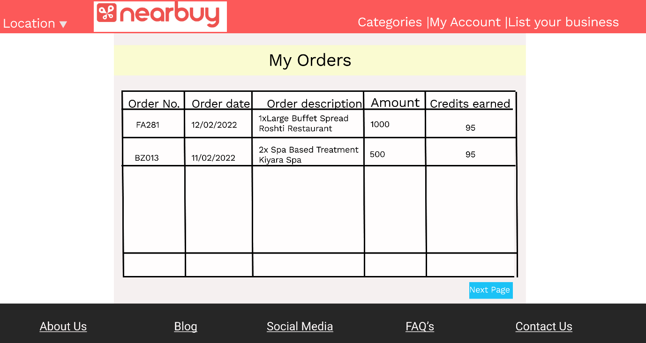

My Orders Page would contain the list of order and their respective rewards

|  |  |  |
| --- | --- | --- |
| **S. No.** | **Feature** | **Description** |
| **1.** | **Order Number** | Contains the order number for the particular order |
| **3.** | **Order Date** | Contains the Date of purchase |
| **3.** | **Order Description** | Contains the description of the purchase |
| **4.** | **Amount** | Contains the amount spent on that purchase |
| **5.** | **Credits Earned** | Contains the amount of credits that were earned for that particular project |

**Logged in Business:**

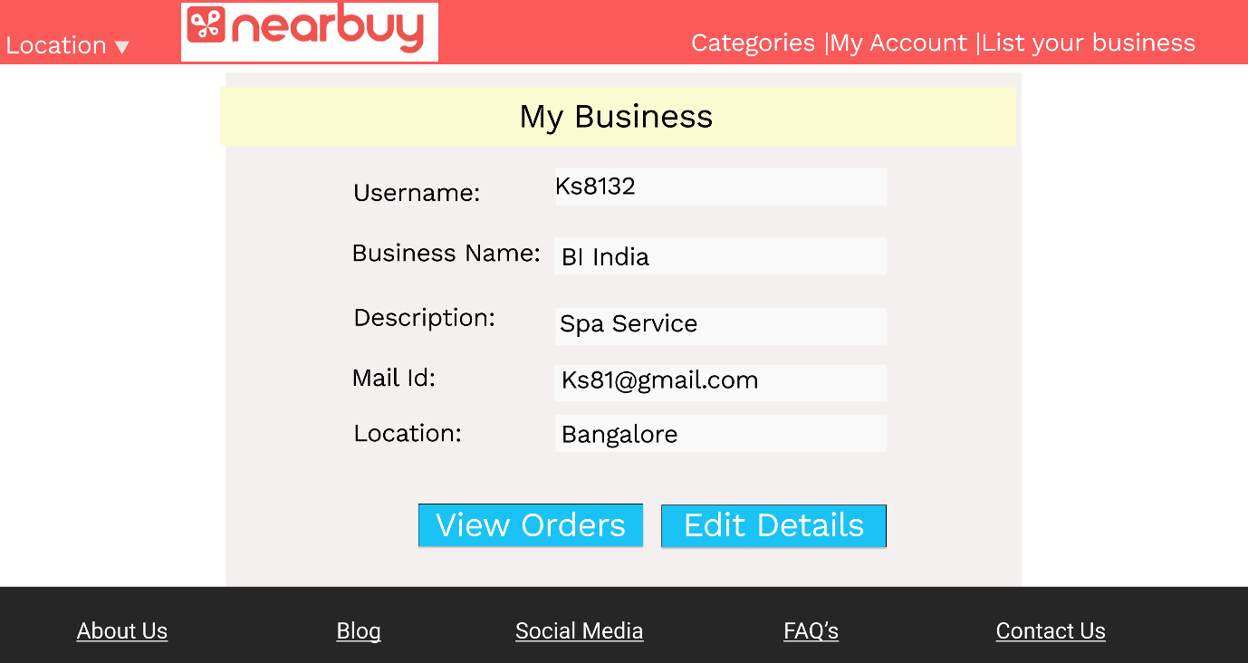

|  |  |  |
| --- | --- | --- |
| **S. No.** | **Feature** | **Description** |
| **1.** | **Username** | Contains the username for the signed in Business User |
| **2.** | **Business Name** | Contains name of the Business |
| **3.** | **Description** | Contains Description of Business |
| **4.** | **Mail-id** | Contains the registered email id |
| **5.** | **Location** | Contains the location of the Business |
| **6.** | **View Orders** | Contains the received orders |
| **7.** | **Edit Orders** | Provides to edit details |

**My Business Orders:**

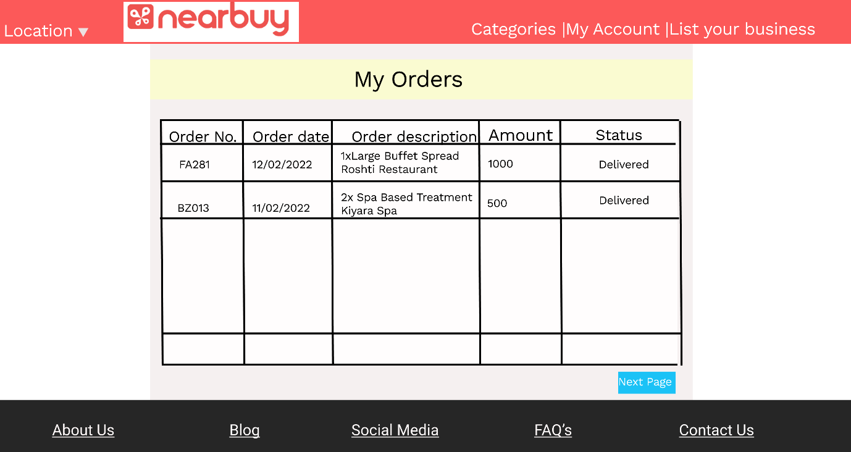

|  |  |  |
| --- | --- | --- |
| **S. No.** | **Feature** | **Description** |
| **1.** | **Order No.** | Contains the number of the order |
| **2.** | **Order Date** | Contains the date of Order |
| **3.** | **Order Description** | Contains the description of order |
| **4.** | **Amount** | Contains the amount of order |
| **5.** | **Status** | Contains the Status of order |
| **6.** | **Next Page** | Next Page redirects to next page |

**My Products:**

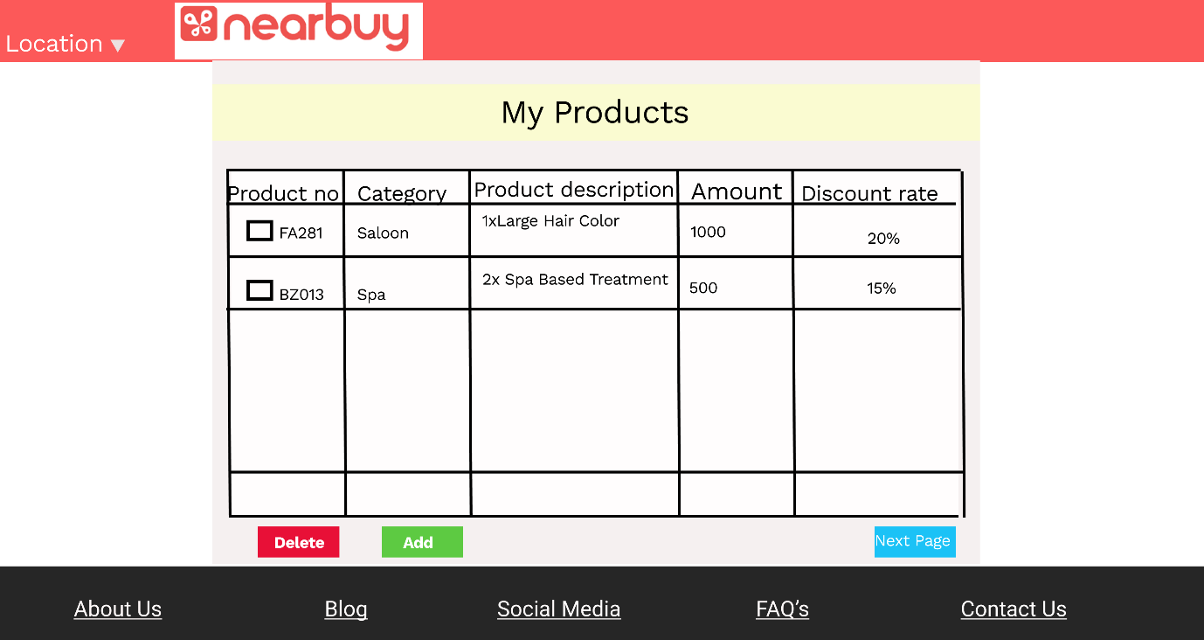

|  |  |  |
| --- | --- | --- |
| **S. No.** | **Feature** | **Description** |
| **1.** | **Product No.** | Contains the number of the Product |
| **2.** | **Category** | Contains the category of Product |
| **3.** | **Product Description** | Contains the description of Product |
| **4.** | **Amount** | Contains the amount of Product |
| **5.** | **Discount** | Contains the discount percentage of product |
| **6.** | **Delete** | It can delete the selected product |
| **7.** | **Add** | It can add the selected product |
| **8.** | **Next Page** | It redirects to next page |

**Support Page(Support) :**

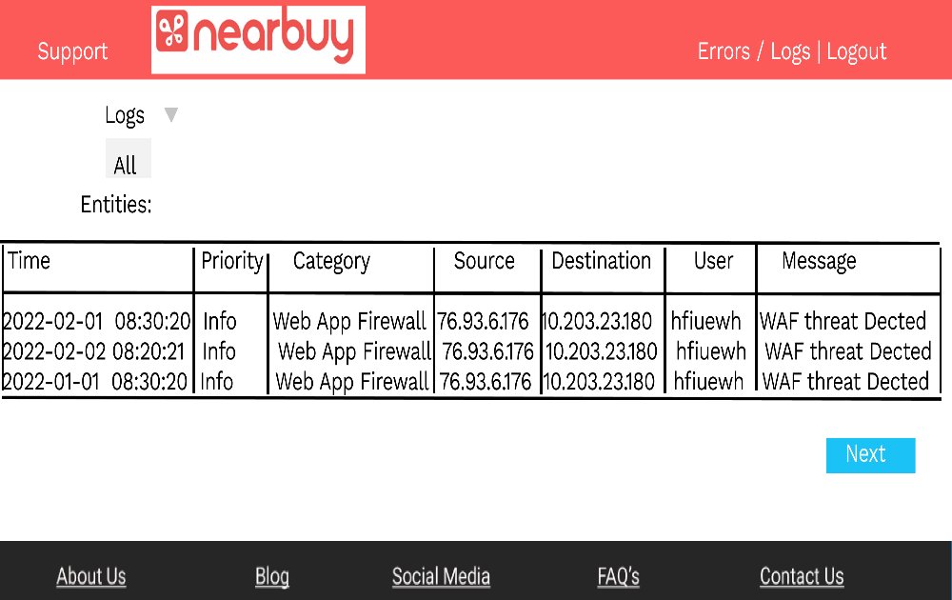

1

Support System aims to support activities and operations of all domains. This can only be accessed by members of the support persona. They have access to view the logs and find any error.

|  |  |  |
| --- | --- | --- |
| S.No | Feature | Description |
| 1 | Log Type | Provides the user the ability to choose the necessary logs |
| 2 | Entity Table | A place where all the logs are displayed |
| 3 | Next Button | Helps in moving to the next page |

**Admin :**

**Role Authoring:**

On Clicking the Role Authoring on the Menu bar, the admin can assign or revoke different Roles from different Users

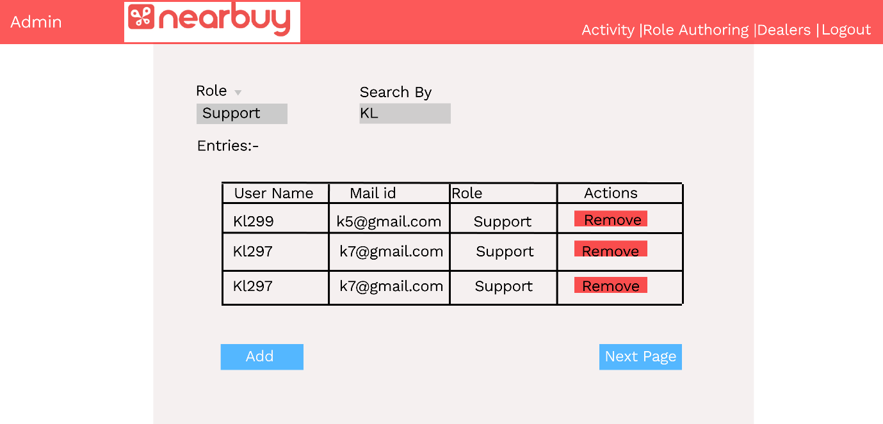

The various features of the Role Authoring Page are mentioned in the table below

|  |  |  |
| --- | --- | --- |
| **S. No.** | **Feature** | **Description** |
| **1.** | **Role** | Contains a dropdown with different roles. The results would be filtered based user’s selection |
| **3.** | **Search By** | Admin can enter the name of the user they want to search |
| **3.** | **Add** | This button enables the admin to add a new user and assign a role to them |
| **4.** | **Remove** | This allows the Admin to remove the respective user |

**Dealers:**

On Clicking the Dealers, admi can approve or reject the Product requests by business

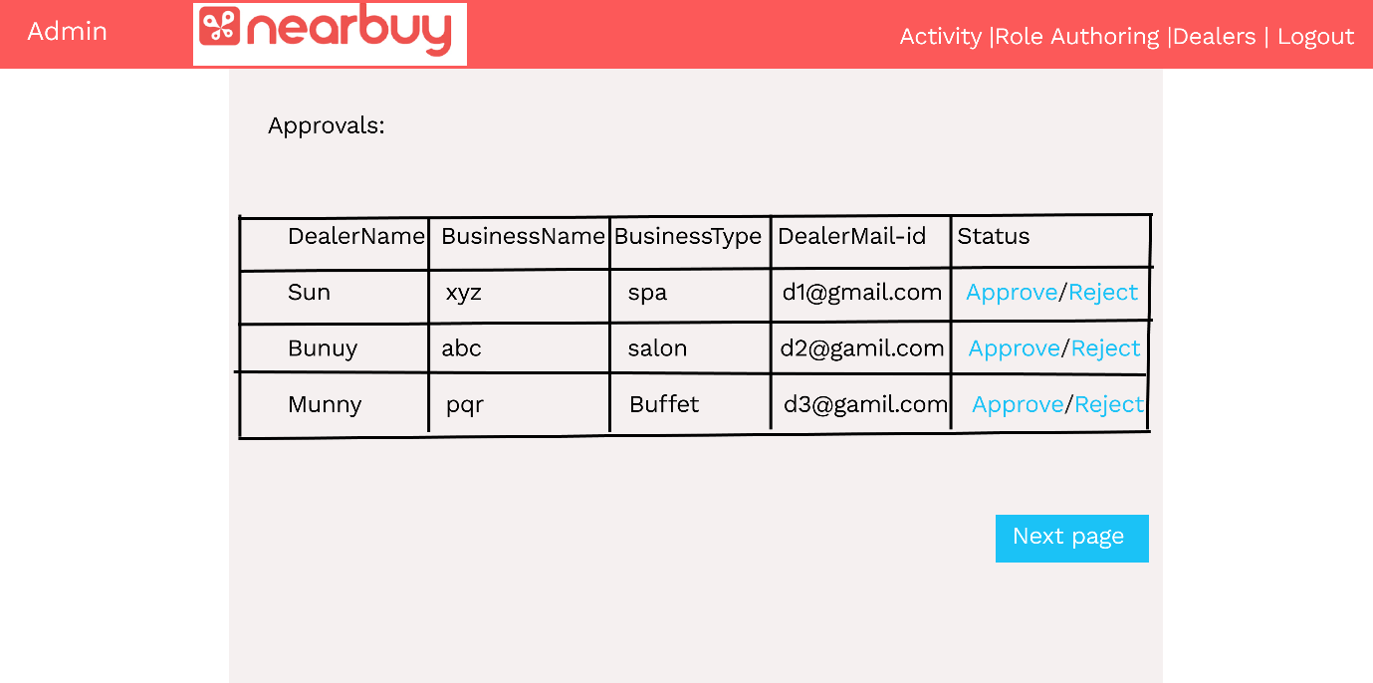

The features for Dealers page are mentioned in the table below:

|  |  |  |
| --- | --- | --- |
| **S. No.** | **Feature** | **Description** |
| **1.** | **Approve** | This would approve the product request and the product would reflect on the customer’s screen |
| **3.** | **Reject** | The request would be rejected |

**Footer:**

The Components of the footer are mentioned below:

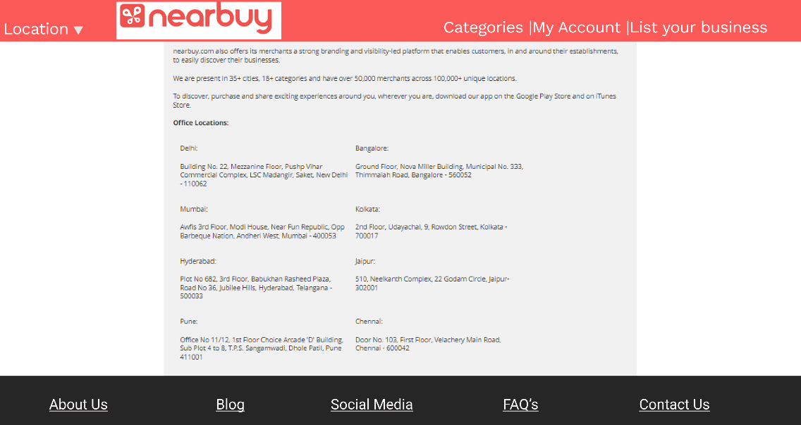

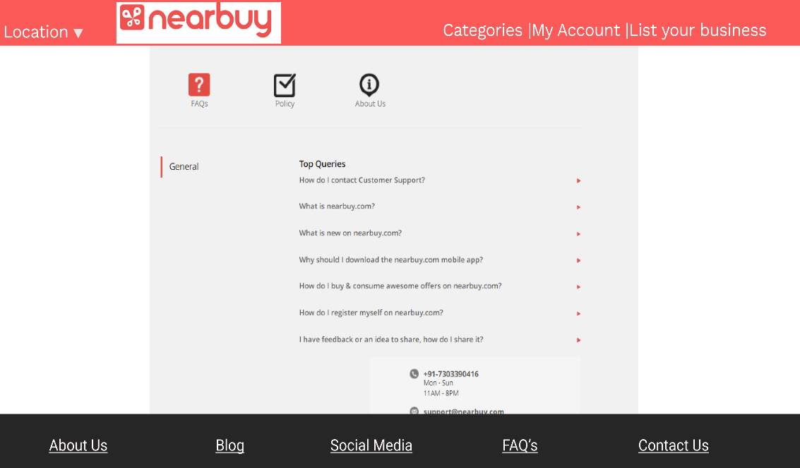

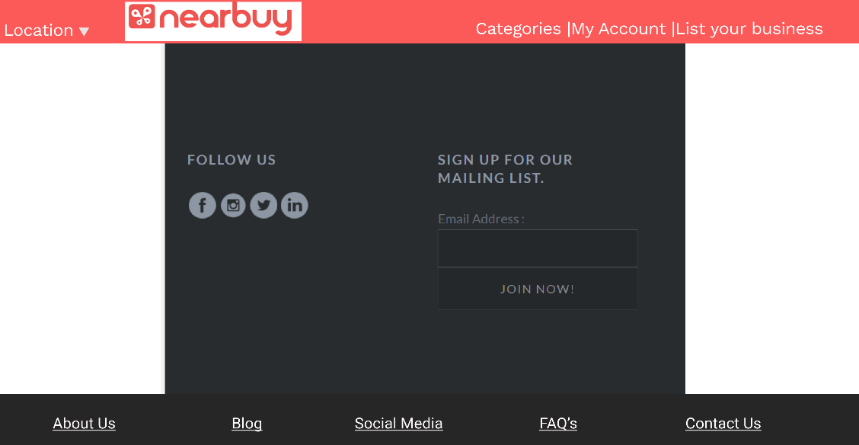

|  |  |  |
| --- | --- | --- |
| **S. No.** | **Feature** | **Description** |
| **1.** | **About Us** | Contains the General description of the Website |
| **3.** | **Blog** | Contains the link to the Website Blog |
| **3.** | **Social Media** | Contains the link to the social Media details |
| **4.** | **FAQ’s** | Contains the link to the FAQ section |
| **5.** | **Contact Us** | Contains the link to the contact information |